Planner III - Environmental

Salary Location
$71,988.80 - $107,972.80 Annually Commerce City, CO

Job Type Department
Full-Time Community Development
Apply here!

THE CITY AND COMMUNITY:
From its beginnings as a junction for railroads and highways, Commerce City, located in Adams County, is now one of the state’s fastest-growing cities, with a population of 64,000--the 18th most populous city in the state. The eventual buildout of this community is 180,000 people and will result in Commerce City being one of Denver’s largest suburbs.
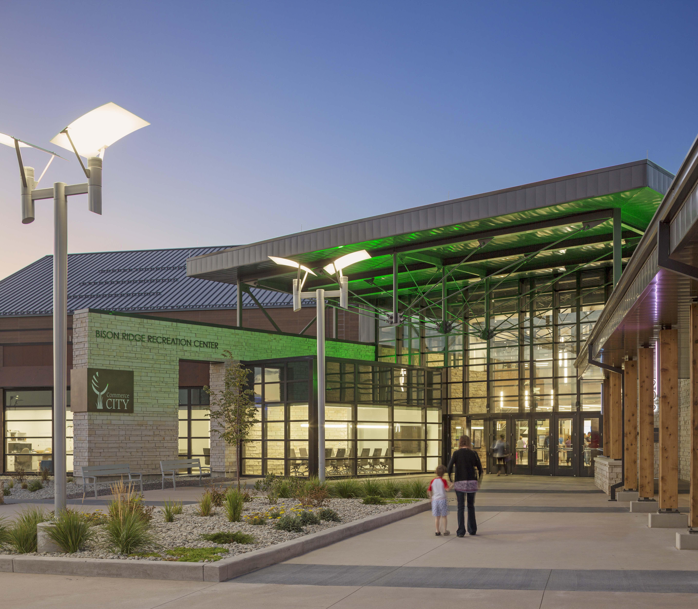
Commerce City is redefining itself for the next generation by building on historic values of community, industry, agriculture, and family. The City is a safe, diverse, and welcoming community with 25 miles of trails, a championship golf course, 840 acres of open space and parks, and 1,300 thriving businesses. In a recent annual resident survey, 80% of respondents feel safe in their neighborhood while 75% rated their neighborhood as a good place to live.
The Commerce City Environmental Planner position has been created to provide leadership and direction for the City’s environmental programs, covering all aspects of the environment and sustainability. The successful candidate will have a bias for action, be a doer, a deal maker, and a creator.
This position develops, recommends, and implements strategies and policies regarding environmental projects, strategic and master plans, and Oil and Gas development within the city. Acts as a case manager for complex land use applications with an environmental component. Creates, coordinates, and manages the social, economic, and environmental aspects of energy, waste reduction, and brownfield programs; fosters relationships with landfill operators, industry groups, special districts, public utility companies; and provides a high level of customer service to the community members and other city departments.
The hiring range for this position is $71,987 - $89,984 annually.

Minimum Qualifications
Master's degree in Planning, Environmental Planning, Public Administration, Urban Design or related field from an accredited college or university and four years of relevant experience, or Bachelor's degree in Planning, Urban Design, Environmental Planning, Public Administration or related field from an accredited college or university with five years of relevant experience. An equivalent combination of training and experience that provides the required knowledge, skills, and abilities may be considered. Minimum of two years’ experience working on environmental or Oil and Gas issues with experience in development and administration of environmental programs and long-term impacts preferred. Must possess a valid driver's license. AICP, LEED AP, EcoDistricts certifications preferred.
The ideal candidate can…  - Create an environmental program for the City that strives to make Commerce City leader in Colorado and the nation in local government environmental efforts.  - Propose policies and ordinance changes which will help achieve the City’s goals of sustainability and energy conservation.  - Research and replicate best practices within the field of environmental sustainability.  - Analyze complex development plans to determine regulatory compliance.  - Administer the City Oil and Gas Program and serve as the City liaison between the Colorado Oil and Gas Conservation Commission.  - Represent Commerce City government, its residents, businesses and non-profits on all energy policy and regulations.  - Report on, collect, manage and evaluate all data related to the oil and gas program, clean energy efforts and relationships with partner agencies.  - Advocate mitigation of significant impacts by land uses, including siting options that address land use conflicts.  - Increase the public’s environmental awareness and understanding by developing outreach materials and presenting information at appropriate locations and events.  - Be the face of Commerce City on all things environmental. | Knowledge, Skills, and Ability  Experience: desired in planning, environmental advocacy, site plan review, regulatory review of oil and gas projects, and most importantly creating working relationships with associates, consultants, contractors, developers and the general public.  Knowledge: zoning, subdivision standards and other principles of land use regulation, relevant state, federal and local laws, rules, regulations, codes and/or statutes, reclamation of sites, brownfield management, and environmental impact issues as well as oil and gas permitting operations; working knowledge of current environmental issues, best practices and trends; the language of urban planning and environmental planning.  Ability: to plan, organize, and carry out complex assignments; to develop and sustain effective working relationships with associates, other local governmental agencies, development community, partner agencies and members of the public; to communicate complex thoughts to all; to negotiate solutions among groups with diverse and conflicting needs; to coordinate multiple projects and tasks, with specific skills in project management; speak in public and to present information and field questions in a sometimes stressful environment, and to focus on the details when necessary.

