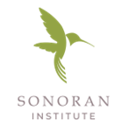

Sonoran Institute is hiring program managers for the Growing Water Smart program, which empowers local governments to adopt plans and policies that integrate water and land use planning and support their community resiliency goals. We are looking to fill two program manager positions and are looking for candidates in Arizona and Colorado. These are fully remote positions.

https://sonoraninstitute.org/careers/

