Town of Camp Verde
Human Resource Department
♦ 473 S. Main Street, Suite 102 ♦ Camp Verde, Arizona 86322 ♦
♦ Telephone: 928.554.0001 ♦ Fax: 928.567.9601♦
♦ www.campverde.az.gov ♦

Community Development Planner

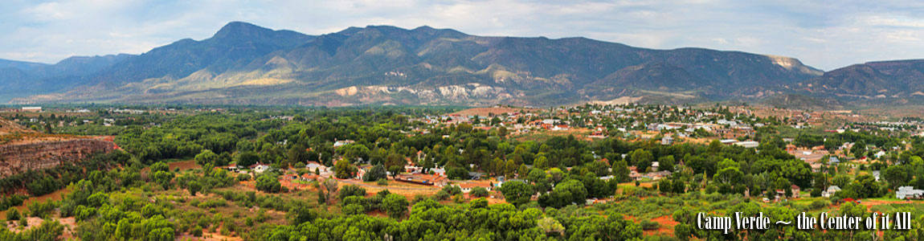
Opportunity $ 46,744 - $57,264 Hiring Range (DOE)

The Town of Camp Verde is looking to fill the exciting role and opportunity of a Planner for the Department of Community Development. We are hoping to find excellent candidates who see this as a chance to move forward in the profession while working in a growing community with many opportunities both professionally and personally.

Major benefits for a full-time regular employee (subject to change):

- Paid Vacation
- Eleven (11) holidays, 88 hours accrued
- Sick time accrued at a rate of 3.69 hours per pay period
- Five (5) health insurance plan options to choose from, 100% paid for employee and 40% paid for dependents
- Dental and Vision plans, 100% paid for employee and 40% paid for dependents
- Health Savings Account (HSA) available
- Employer paid life insurance with additional voluntary life available
- Arizona State Retirement (ASRS) and long-term disability benefits

The Department
The Town of Camp Verde is a full-service community staffed by very dedicated staff who serve a population of over 12,000 citizens in the Verde Valley in the center of Arizona. Camp Verde is a quiet, safe place to raise your children, with a small-town atmosphere, a friendly relaxed, no-pressure way of life. Additionally, we have wide-open spaces, the Verde River, a mild 4-season climate and panoramic views from the vistas above our valley.
General Description of Position
Qualifications
Under general supervision, performs professional urban planning work in the Town of Camp Verde, and explains planning and zoning regulations and municipal standards for land use, development projects and technical issues; assures compliance to state and Federal regulations, and Town policies, procedures and goals.
• Provides professional planning services, and reviews technical documents for compliance with Town standards; produces reports, presentations and recommendations on planning issues; reviews development proposals, subdivision plats, applications, zoning changes, and other land use applications; advises applicants within scope of authority and training.
• Prepares and presents project reports to the Town Council and regional boards and commissions; prepares technical ordinance and resolution documents for review; maintains and administers planning projects; reviews and processes applications, plans and project proposals, and tracks inter-departmental review process.
• Responds to questions from residents and provides information and customer service; investigates and resolves inquiries and complaints, enforces rules and regulations, and explains Community Development Department policies, codes, standards and procedures; monitors and reviews trends in planning and development programs, and recommends improvements.
• Coordinates addressing issues, zoning applications, and construction inspections; maintains and updates Town General Plan and ordinances.

Qualifications
Education and Experience:
Bachelor’s Degree in Urban Planning, Engineering, Business or Public Administration, or related field; AND one year experience in planning and development programs; OR an equivalent combination of education and experience.

Required Licenses or Certifications:
- Must possess State of Arizona Driver's license.
- Professional certification through the American Institute of Certified Planners (AICP) is preferred; depending on the needs of the Town, incumbent may be required to obtain additional technical certifications.

Required Knowledge of:
- Town policies and procedures.
- Policies, procedures, regulations, operations, and services of Community Development Department.
- Principles of land use planning and urban design.
- Federal, State and local laws, rules, codes and regulations governing planning, zoning, building, safety, code enforcement, community planning and economic development.
- Town land use and development regulations, zoning codes, planning concepts and principles.
- Occupational hazards and safety precautions.
- Record keeping and file maintenance principles and procedures.

Required Skill in:
- Analyzing planning issues and making logical recommendations based on findings.
- Interpreting and applying development standards and procedures, Federal and state rules and regulations, and Town policies and procedures.
- Presenting and defending reports and information in a public speaking setting such as public hearings and neighborhood meetings.
- Reading and interpreting building plans and technical specifications, and checking details, estimates, plans, and specifications of projects.
- Establishing and maintaining cooperative working relationships with employees, officials, contractors, other development agencies and the general public.
- Maintaining accurate and interrelated technical and computerized records.
- Communicating clearly and concisely, both verbally and in writing.

Physical Demands / Work Environment:
- Work is typically performed in a standard office environment.
- Requires site inspections and evaluations for projects and applications.

Selection Process
A Town application, cover letter and resume are all required. You may complete an application online and submit any additional documentation to www.governmentjobs.com/careers/campverde. Open until filled, first review Monday, October 17th, 2022.

Current projected review process intended to include narrowing to 3 (approximately) candidates that will go through an oral board interview(s), and background review before final selection.

